Publish Date: July 3 or July 4 , 2017

Title: Can Fusion 360 save or load my local model?

Content:

My friend told me can input command “Options.DebugEnvironment /show” on the bottom of text commands window with txt mode

Then you will find two buttons: “Open a document” , “Save Local” on the top menu of Fusion like below picture showed.

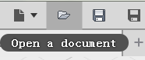 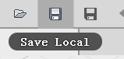

It is a very useful command that I used on Fusion and convenient to can save and open my model on local! Also take effect on current version 2.0.4279.